10 Reasons You Should Never Drink Soda
Whether you're a fan of diet or regular, soda may be worse for you than you think
3.75
8 ratings
Feb 12, 2014 | 3:58 pm
By
Dr. Verma
Staff Writer
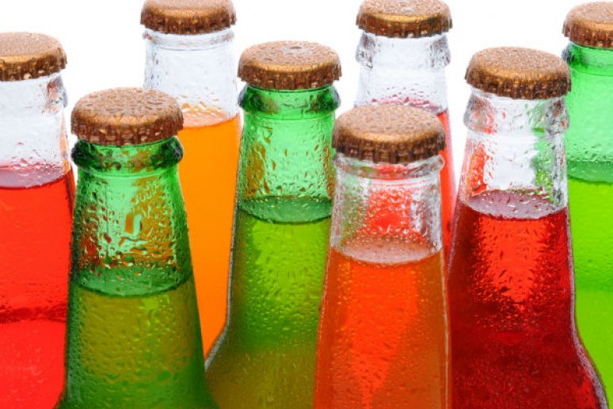
Shutterstock
Whether bottled or canned, sugar-free or regular, and no matter what the color — sodas can be very problematic.
The health dangers of soda have long existed: whether they are regular or diet, caffeinated or caffeine-free, soda is just plain bad news. Willingly drinking soda is almost like opting to smoke: if you know how harmful it is, then why do it? Here are some reasons that will make you think twice before reaching for soda, whatever variety or flavor it may be.
10 Reasons You Should Never Drink Soda (Slideshow)
Most sodas have caffeine which has a number of detrimental effects on the body such as increase in blood pressure, heart palpitations, migraines, breast tenderness, urinary problems, just to name a few.
One can of regular soda holds approximately 33 grams or 10 teaspoons of sugar. Can you imagine how much insulin your body needs to make to combat the excess sugar? Over time, this has disastrous consequences, often leading to obesity, diabetes, insulin resistance, and heart disease. Even one soda daily can lead to these long-term issues, thus causing a downward spiral of health.
Most sodas contain high fructose corn syrup, which is a byproduct of corn. High fructose corn syrup is manufactured using traces of mercury: there don’t need to be any further comments on that.
Soda has phosphoric acid which antagonizes calcium, leading toosteoporosis, bone loss, and dental decay. Phosphoric acid messes with the stomach, blocking normal digestion and inhibiting nutrient absorption. It leads to kidney problems, muscle loss, and accelerated aging. Too much phosphoric acid can lead to premature death, and this effect was validated in a study published in FASEB Journal in 2010, using lab rats. This is very disturbing considering that some soda manufacturers have been increasing phosphoric acid in sodas recently, as it helps improve their shelf life.
Diet sodas are not a healthy alternative. While they may understandably sound better — diet soda commercials may lead you to believe that you won't be ingesting the extra calories that will cause weight gain, this doesn’t actually work. Aspartame is typically used as the sugar substitute, which ironically is more harmful than sugar: aspartame may be incredibly toxic, and has been associated with everything from cancer — in a study published in Environmental Health Perspectives — to mood disorders — in a study published in Biological Psychology.
Artificial sweeteners do not break down in the body. So what happens? It enters water supplies. Scientists in Switzerland tested waste water treatment plants, rivers, lakes and found alarming levels of sucralose, saccharin and acesulfame K. Though the effects on humans are not clear yet, the artificial sweeteners found in water interferes with other organisms feeding habits.
Forget about beer belly, you can also get diet soda belly.Researchers from the University of Texas Health Science Center studied 475 adults over ten years. They noted a 70 percent increase in waist circumference compared to non-soda drinkers. Those who consumed two or more diet sodas daily resulted in a whopping 500% increase in weight size. Not cool.

MORE ON HEALTH AND WELLNESS
- Surprising Reasons You Should Cut Back on Coffee
- 12 Yoga Poses to Cure Your Hangover
- Why You Should Stop Drinking Milk Right Now
- Spicing Up Your Drinks for Better Health
- Dr. Verma’s Verdict: Juice Cleanses — Hype or Healthy?
Soda cans have bisphenol A (BPA), which prevents acids from reacting with metal. BPA is linked to altering hormones,obesity, cancers andinfertility.
You think switching from soda cans to plastic soda bottles is better? Think again. Plastic soda bottles and unrecycled plastic caps cause widespread damage to sea and wildlife, especially birds. The "Great Pacific Garbage Patch" is a mass of plastic debris in the Pacific Ocean and is responsible for thousands of animals dying each year unnecessarily, due to human ignorance.
The caramel coloring found in many sodas is known to cause cancer. Two of these carcinogens are 2-methylimidazole and 4-methylimadazole. According to California's Strict Proposition 65 list of chemicals known to cause cancer, only 16 micrograms per person per day of 4-methylimidazole is enough to cause cancer, and there is 200 micrograms in a 20 ounce bottle!

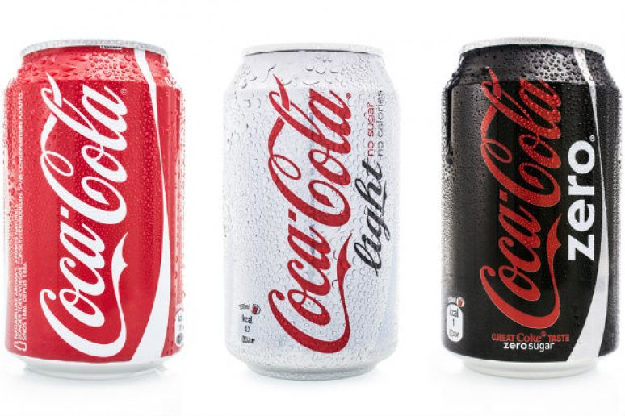
10 Reasons You Should Never Drink Soda (Slideshow)

Though Mountain Dew may not have the caramel coloring,it has brominated vegetable oil (BVO), which is an industrial chemical used as flame retardant. This is also used in Gatorade, although Gatorade has stated that it will be removing this substance in the near future. Would you drink that? Or worse, allow kids to drink it? Researchers are suspecting that BVO accumulates in body fat and may lead to infertility, behavioral problems and heart muscle injury.
Deepa Verma, MD, recently opened up her new integrative medical practice, Synergistiq Integrative Health, in Clearwater, Florida. Dr. Verma believes that healthy and holistic living is the key to happiness and aging gracefully.

