What's Really Inside That Cinnabon Classic Cinnamon Roll?

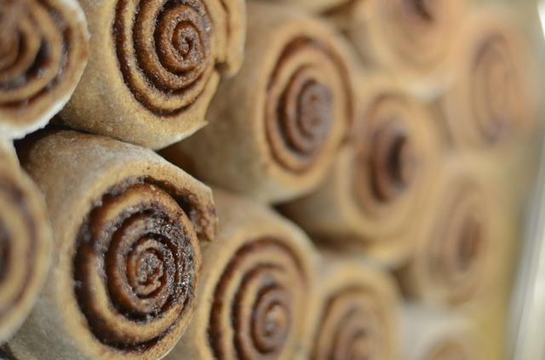

Last Updated: Jun 15, 2015 | By Cristina Goyanes
THE SUSPECT: Cinnabon Classic Cinnamon Roll
THE DETECTIVES: Mira Calton and Jayson Calton, a husband-and-wife team whose latest book, "Rich Food, Poor Food," is the sequel to their bestselling "Naked Calories." The nutrition duo studied more than 150 ingredients in 100 countries on seven continents during a six-year expedition.
NUTRITION LABEL: 880 calories, 36 grams of fat, 127 grams of carbs, 59 grams of sugar, 830 milligrams of sodium, 2 grams of fiber
LISTED INGREDIENTS: Enriched flour (wheat flour, malted barley flour, niacin, iron, thiamin mononitrate, riboflavin, folic acid), water, brown sugar, palm oil, milk, soy bean oil, yeast, salt, whey, soy lecithin, cinnamon, powdered sugar, vegetable mono and diglycerides, sodium benzoate, vitamin A palmitate, cream, cream cultures, carob bean gum, corn starch, natural and artificial flavor.*
*May also contain: Egg white, whole eggs, buttermilk, molasses, sodium stearoyl lactylate, buttermilk, azodicarbonamide, beta carotene, high fructose corn syrup (glucose-fructose), wheat protein isolate (wheat gluten lactic acid, sulfites), vital wheat gluten, hydroxpropyl methylcellulose, acetylated tartaric acid esters of mono and diglycerides (datem), baking soda, xanthan gum, guar gum, beta carotene, glucono delta-lactone, citric acid, propionic acid, enzymes (amylase), ascorbic acid sorbitan monostearate, cellulose gum, potassium sorbate, soy oil, polysorbate 60, lactic acid, artificial color.

UNDER THE SPOTLIGHT
WHEAT GLUTEN (plus Vital Wheat Gluten): As first pointed out in the Caltons' earlier investigation of the Egg McMuffin from McDonald's, wheat isn't what it used to be. Today's genetically modified grains will not only spark an addiction (you'll want to keep eating more grains and sugars), but they will also encourage you to eat an average of 400 extra calories a day. Anther not-so-lovely perk of including this ingredient in your diet: It may cause a leaky gut, which can lead to immune problems and possibly arthritis -- not to mention the risk of developing a roll of your own (aka "a muffin top") from eating this sweet roll.
SUGAR: As noted earlier, a Cinnabon Classic Cinnamon Roll is a straight-up sugar factory. Inside, you'll find four different types of the insulin-spiking ingredients: brown sugar, powdered sugar, high fructose corn syrup (glucose-fructose) and molasses. The worst part is that these sugars will rob your body of crucial vitamins and minerals, including vitamin C, chromium, magnesium, zinc and copper. To top it off, high fructose corn syrup infamously may not be triggering leptin, your “I'm full” hormone. In other words, you'll want to continue to stuff your face even if your stomach is completely full.
GMOs: The Caltons' count nine potentially genetically modified organisms -- including soy, corn and sugar -- in just one Cinnabon. OMG, that's a lot of GMOs! As a general rule, you want to avoid GMOs, which have been linked to health problems. The worst offenders in the bunch are the diacetyl tartaric acid esters of monoglycerides and diglycerides (or DATEM), which are emulsifiers that help extend the shelf life of processed foods. Doesn't sound so bad? Well, wait until you hear that they're basically trans-fatty acids in disguise. Because they're not technically considered a lipid or a fat, they avoid being labeled as such, thereby dodging the serious scrutiny that comes with trans-fats, which are associated with heart disease, stroke, obesity and diabetes. Another troublemaker is sodium benzoate, which is also used for preservation reasons. It may cause allergic reactions, such as hives and asthma, and may promote the formation of a carcinogen called benzene.
NON-ORGANIC DAIRY: Made with cream, cheese cultures, whey and buttermilk, this dessert is likely packed with rBGH synthetic growth hormones, a treatment given to cows to boost milk production. These same cows are also likely given antibiotics to stave off hormone-related health issues, such as inflamed and infected udders. Consuming these super-charged cow byproducts may increase the human risk of breast, colon and prostate cancers.
AZODICARBONAMIDE: Unless you don't mind eating the same ingredient that's used in your yoga mat and sneaker soles, you'll want to avoid this additive. Its main purpose is to whiten the flour quickly. While its use is legal in the United States, azodicarbonamide is banned as a food additive in Europe in Australia. The Republic of Singapore also identifies azodicarbonamide as posing a health risk: The country banned this product, but it also invoked a serious penalty -- up to 15 years in prison and a $450,000 fine -- for using the asthma-causing allergen.
THE VERDICT: Guilty as sweet sin.
THE SENTENCE: If you're thinking, "One Cinnabon Cinnamon roll every blue moon won't kill me," you're absolutely right. But consider this: Is it really worth poisoning yourself, even just a little bit? For a sweet cinnamon fix, consider sprinkling some organic cinnamon (cinnamon labeled as organic cannot be harvested from bioengineered plants -- i.e. GMOs -- and it cannot be subjected to ionizing radiation), which is a good source of vitamins, minerals, and antioxidants, over a plain organic yogurt or natural peanut butter spread on celery sticks.

